**Lab Assignment No. 11**

**Code:**

import tensorflow as tf  
from tensorflow import keras  
from keras import Sequential  
from keras.layers import Dense, Dropout  
from sklearn.datasets import make_gaussian_quantiles  
import numpy as np  
import pandas as pd  
import matplotlib.pyplot as plt  
import seaborn as sns

X1, y1 = make_gaussian_quantiles(cov=3.,  
 n_samples=10000, n_features=2,  
 n_classes=2, random_state=1)  
X1 = pd.DataFrame(X1,columns=['x','y'])  
y1 = pd.Series(y1)

X1

x y  
0 0.759772 1.418316  
1 2.429896 -2.974839  
2 -1.312662 -3.837630  
3 1.544247 0.904236  
4 0.675905 3.471664  
... ... ...  
9995 -1.519436 -0.076489  
9996 -2.862951 1.931277  
9997 -0.977937 0.364132  
9998 -3.888984 -2.809069  
9999 0.075637 -0.391988  
  
[10000 rows x 2 columns]

y1

0 0  
1 1  
2 1  
3 0  
4 1  
 ..  
9995 0  
9996 1  
9997 0  
9998 1  
9999 0  
Length: 10000, dtype: int64

sns.scatterplot(x=X1.iloc[:,0], y=X1.iloc[:,1], hue=y1)

<Axes: xlabel='x', ylabel='y'>

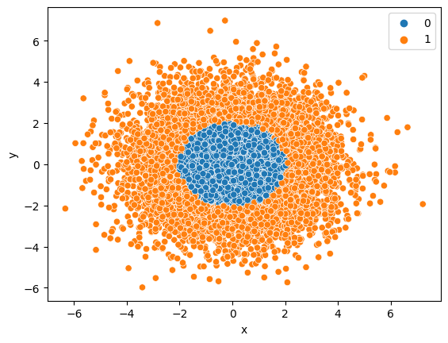

model = Sequential()  
model.add(Dense(32, activation='relu', input_dim=2))  
model.add(Dense(16, activation='relu'))  
model.add(Dense(8, activation='relu'))  
model.add(Dense(1, activation='sigmoid'))

from keras.utils import plot_model  
plot_model(model, show_shapes=True)

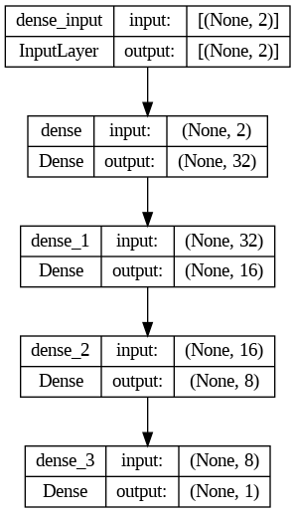

model.compile(optimizer='adam', loss="binary_crossentropy", metrics=['accuracy'])

model.fit(X1, y1, epochs=50, verbose=1)

**Output:**

Epoch 1/50  
313/313 [==============================] - 5s 5ms/step - loss: 0.4545 - accuracy: 0.7580  
Epoch 2/50  
313/313 [==============================] - 2s 5ms/step - loss: 0.0947 - accuracy: 0.9822  
Epoch 3/50  
313/313 [==============================] - 1s 4ms/step - loss: 0.0521 - accuracy: 0.9877  
Epoch 4/50  
313/313 [==============================] - 2s 6ms/step - loss: 0.0415 - accuracy: 0.9879  
Epoch 5/50  
313/313 [==============================] - 1s 3ms/step - loss: 0.0345 - accuracy: 0.9903  
Epoch 6/50  
313/313 [==============================] - 1s 4ms/step - loss: 0.0313 - accuracy: 0.9911  
Epoch 7/50  
313/313 [==============================] - 1s 3ms/step - loss: 0.0284 - accuracy: 0.9900  
Epoch 8/50  
313/313 [==============================] - 1s 3ms/step - loss: 0.0268 - accuracy: 0.9912  
Epoch 9/50  
313/313 [==============================] - 1s 3ms/step - loss: 0.0243 - accuracy: 0.9912  
Epoch 10/50  
313/313 [==============================] - 1s 3ms/step - loss: 0.0241 - accuracy: 0.9907  
Epoch 11/50  
313/313 [==============================] - 1s 3ms/step - loss: 0.0230 - accuracy: 0.9918  
Epoch 12/50  
313/313 [==============================] - 1s 5ms/step - loss: 0.0210 - accuracy: 0.9920  
Epoch 13/50  
313/313 [==============================] - 2s 6ms/step - loss: 0.0211 - accuracy: 0.9924  
Epoch 14/50  
313/313 [==============================] - 1s 3ms/step - loss: 0.0223 - accuracy: 0.9920  
Epoch 15/50  
313/313 [==============================] - 1s 3ms/step - loss: 0.0187 - accuracy: 0.9935  
Epoch 16/50  
313/313 [==============================] - 1s 4ms/step - loss: 0.0176 - accuracy: 0.9935  
Epoch 17/50  
313/313 [==============================] - 2s 5ms/step - loss: 0.0196 - accuracy: 0.9930  
Epoch 18/50  
313/313 [==============================] - 1s 3ms/step - loss: 0.0193 - accuracy: 0.9921  
Epoch 19/50  
313/313 [==============================] - 1s 3ms/step - loss: 0.0171 - accuracy: 0.9936  
Epoch 20/50  
313/313 [==============================] - 1s 2ms/step - loss: 0.0164 - accuracy: 0.9937  
Epoch 21/50  
313/313 [==============================] - 1s 2ms/step - loss: 0.0183 - accuracy: 0.9929  
Epoch 22/50  
313/313 [==============================] - 1s 2ms/step - loss: 0.0177 - accuracy: 0.9924  
Epoch 23/50  
313/313 [==============================] - 1s 2ms/step - loss: 0.0195 - accuracy: 0.9920  
Epoch 24/50  
313/313 [==============================] - 1s 2ms/step - loss: 0.0174 - accuracy: 0.9927  
Epoch 25/50  
313/313 [==============================] - 1s 2ms/step - loss: 0.0144 - accuracy: 0.9948  
Epoch 26/50  
313/313 [==============================] - 1s 3ms/step - loss: 0.0169 - accuracy: 0.9936  
Epoch 27/50  
313/313 [==============================] - 1s 3ms/step - loss: 0.0171 - accuracy: 0.9928  
Epoch 28/50  
313/313 [==============================] - 1s 3ms/step - loss: 0.0148 - accuracy: 0.9946  
Epoch 29/50  
313/313 [==============================] - 1s 2ms/step - loss: 0.0174 - accuracy: 0.9930  
Epoch 30/50  
313/313 [==============================] - 1s 2ms/step - loss: 0.0137 - accuracy: 0.9948  
Epoch 31/50  
313/313 [==============================] - 1s 2ms/step - loss: 0.0170 - accuracy: 0.9935  
Epoch 32/50  
313/313 [==============================] - 1s 2ms/step - loss: 0.0146 - accuracy: 0.9943  
Epoch 33/50  
313/313 [==============================] - 1s 2ms/step - loss: 0.0160 - accuracy: 0.9935  
Epoch 34/50  
313/313 [==============================] - 1s 2ms/step - loss: 0.0145 - accuracy: 0.9938  
Epoch 35/50  
313/313 [==============================] - 1s 2ms/step - loss: 0.0177 - accuracy: 0.9928  
Epoch 36/50  
313/313 [==============================] - 1s 2ms/step - loss: 0.0173 - accuracy: 0.9927  
Epoch 37/50  
313/313 [==============================] - 1s 2ms/step - loss: 0.0166 - accuracy: 0.9924  
Epoch 38/50  
313/313 [==============================] - 1s 2ms/step - loss: 0.0139 - accuracy: 0.9942  
Epoch 39/50  
313/313 [==============================] - 1s 2ms/step - loss: 0.0133 - accuracy: 0.9944  
Epoch 40/50  
313/313 [==============================] - 1s 2ms/step - loss: 0.0140 - accuracy: 0.9942  
Epoch 41/50  
313/313 [==============================] - 1s 2ms/step - loss: 0.0123 - accuracy: 0.9957  
Epoch 42/50  
313/313 [==============================] - 1s 2ms/step - loss: 0.0155 - accuracy: 0.9932  
Epoch 43/50  
313/313 [==============================] - 1s 2ms/step - loss: 0.0145 - accuracy: 0.9937  
Epoch 44/50  
313/313 [==============================] - 1s 2ms/step - loss: 0.0156 - accuracy: 0.9927  
Epoch 45/50  
313/313 [==============================] - 1s 2ms/step - loss: 0.0148 - accuracy: 0.9938  
Epoch 46/50  
313/313 [==============================] - 1s 2ms/step - loss: 0.0137 - accuracy: 0.9948  
Epoch 47/50  
313/313 [==============================] - 1s 3ms/step - loss: 0.0158 - accuracy: 0.9931  
Epoch 48/50  
313/313 [==============================] - 1s 3ms/step - loss: 0.0174 - accuracy: 0.9924  
Epoch 49/50  
313/313 [==============================] - 1s 3ms/step - loss: 0.0137 - accuracy: 0.9940  
Epoch 50/50  
313/313 [==============================] - 1s 2ms/step - loss: 0.0170 - accuracy: 0.9925

<keras.callbacks.History at 0x7f2618d1c5b0>

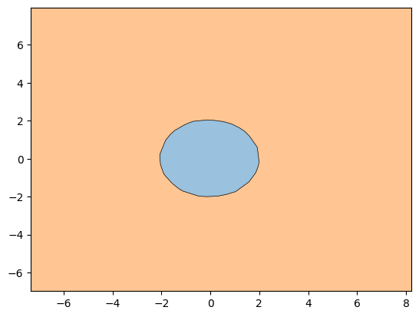

model.predict(X1)

313/313 [==============================] - 0s 1ms/step

array([[2.0704062e-08],  
 [1.0000000e+00],  
 [1.0000000e+00],  
 ...,  
 [4.4519486e-14],  
 [1.0000000e+00],  
 [8.1487582e-16]], dtype=float32)

loss, accuracy = model.evaluate(x=X1, y=y1)

313/313 [==============================] - 1s 3ms/step - loss: 0.0201 - accuracy: 0.9911

print(f"Model having Loss of {loss} and accuracy with {accuracy}")

Model having Loss of 0.020140156149864197 and accuracy with 0.991100013256073